**Indiana University Southeast**

**2021-22 CSCI Capstone Project**

**Workshop Management Web Application**

**Sponsor: Dr. Suranga Hettiarachchi**

**Software Architecture Specification**

**James Schlesener**

**Overview**

This document provides an overview of the architecture for the Workshop Management system. The software will allow the user to manage their workshops along with the people and equipment used within each workshop.

**Subsystem Decomposition**

The subsystems consist of the browser and the server. The browser will consist of the user interface written using the Angular framework that the user will interact with to retrieve and update the contents of the database. The server will consist of the server-side scripts written in Node.js which will process HTTP requests from the browser by writing to or reading from the SQL database.

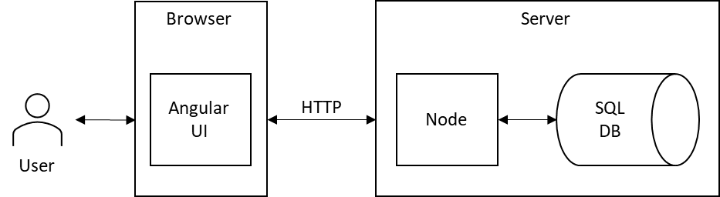

**Hardware Software Mapping**

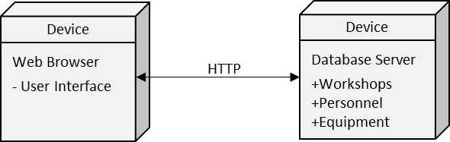

**Persistent Data Management**

All of the data will be persistent and stored in the SQL database. The database will consist of tables to store workshops, personnel, and equipment. In addition to these 3 tables, there will be a WorkshopDetails table (many to many relationship) to store the names of the people attending the workshops and a EquipmentDetails table (many to many relationship) to store the equipment that is given out to the people attending the workshops.

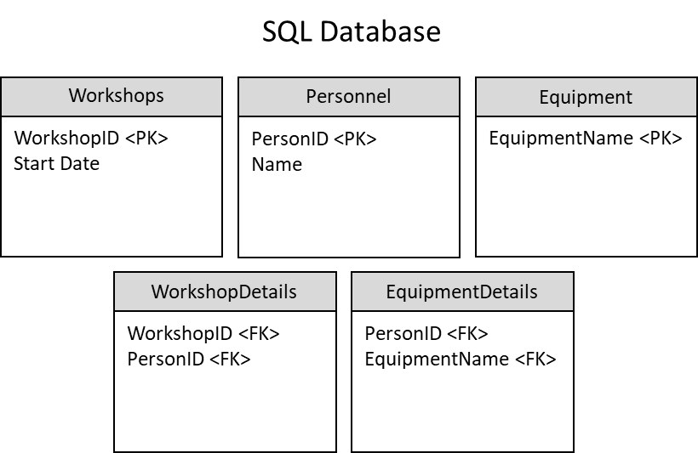

**Access Control and Security**

This software is designed for the person overseeing the workshops. The user of this software will have full access to all operations and data. There will not be any private information stored. Therefore, authentication and security provisions will not be necessary.

**Global Software Control**

The control flow for this software is event-driven. The main screen shows a list of all of the workshops. There will be an option to add a workshop. If workshops exist, there will be options to delete a workshop and to view a workshop. If a workshop is selected to view, it will take the user to a new screen which will show all of the details of the workshop. There will be an option to add a person to the workshop. If people are already assigned to the workshop, there will be options to delete a person and to assign equipment to a person. If equipment is already assigned to a person, there will be an option to delete equipment from a person.

**Boundary Conditions**

The system will start up in the user’s web browser. There won’t be any need to shut the system down. The user will close their web browser when they are done. Input validation will be done to prevent errors and exceptions. There won’t be any daily, weekly, monthly, or yearly efforts to maintain the software. There will be procedures in place to bulk dump all of the data from the SQL database to a file and to load all of the data into the database from the file.